OUTPUT
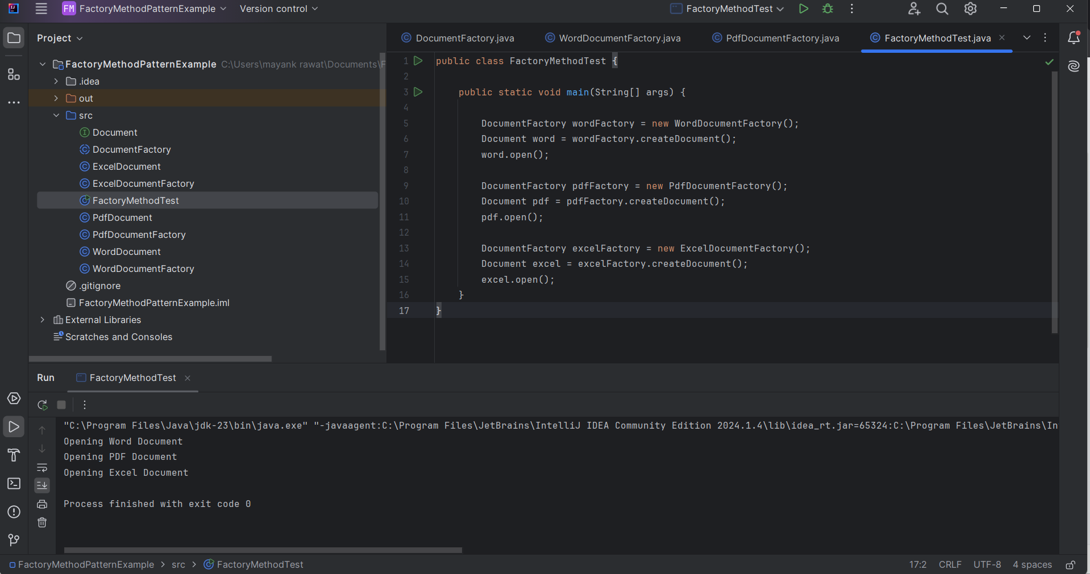

CODE
DocumentFactory
public abstract class DocumentFactory {

public abstract Document createDocument();
}

ExcelDocument

public class ExcelDocument implements Document {

@Override
public void open() {
System.out.println("Opening Excel Document");
}
}
ExcelDocumentFactory
public class ExcelDocumentFactory extends DocumentFactory {

@Override
public Document createDocument() {
return new ExcelDocument();
}
}

FactoryMethodTest

public class FactoryMethodTest {

public static void main(String[] args) {

DocumentFactory wordFactory = new WordDocumentFactory();
Document word = wordFactory.createDocument();
word.open();

DocumentFactory pdfFactory = new PdfDocumentFactory();
Document pdf = pdfFactory.createDocument();
pdf.open();

DocumentFactory excelFactory = new ExcelDocumentFactory();
Document excel = excelFactory.createDocument();
excel.open();
}
}

PdfDocument

public class PdfDocument implements Document {

@Override
public void open() {
System.out.println("Opening PDF Document");
}
}

PdfDocumentFactory
public class PdfDocumentFactory extends DocumentFactory {

@Override
public Document createDocument() {
return new PdfDocument();
}
}

WordDocument
public class WordDocument implements Document {

@Override
public void open() {
System.out.println("Opening Word Document");
}
}
WordDocumentFactory
public class WordDocumentFactory extends DocumentFactory {

@Override
public Document createDocument() {
return new WordDocument();
}
}

